Position: Head Accountant - In charge
Name of Firm: Prantik Care the Earth Geo-info Solutions Pvt. Ltd.
Name of Expert: Suchandan Ghosh
Profession: Accounting
Date of Birth: 25.07.1992
Years with Firm/Entity: 5th March, 2024 Nationality: Indian
Membership in Professional Societies: No
Detailed Tasks Assigned: 1.All transactions / Records maintain and take necessary step into company financial.
2. GST return and TDS payment, Staff salary payment sheet ready monthly wise.
3. All Project /Balance sheet data prepare and support as MIS
4.Manage Accounting Dept Work and Staff
Sl. No | Name of the Examination | Board/Authority | Year of Passing
1 | Diploma in CIA | ICA Durgapur | 2017
2 | B.Com(Hons) | Burdwan University | 2014
3 | Higher Secondary | W.B.B.H.S.E | 2010
4 | Secondary | W.B.B.S.E | 2008
Employment Record:
23feb,2022 | Accountant at J.M.MT.C.D.C.T (Sfurti) in Silda, Jhargram for 2 years.
1/3/2022 to 28/02/2024 | Sr. Accountant post for one year at Santiniketan Medical Centre, located at Kashipur Bypass, Bolpur, Birbhum.
Languages:
Language Known | Reading | Writing | Speaking
English | Excellent | Good | Average
Bengali | Excellent | Excellent | Excellent
Hindi | Excellent | Poor | Average
Certification:
I, the undersigned, certify that to the best of my knowledge and belief, these data correctly describe me, my qualifications, and my experience. If awarded the Contract, I undertake to work with this Firm only on this assignment.
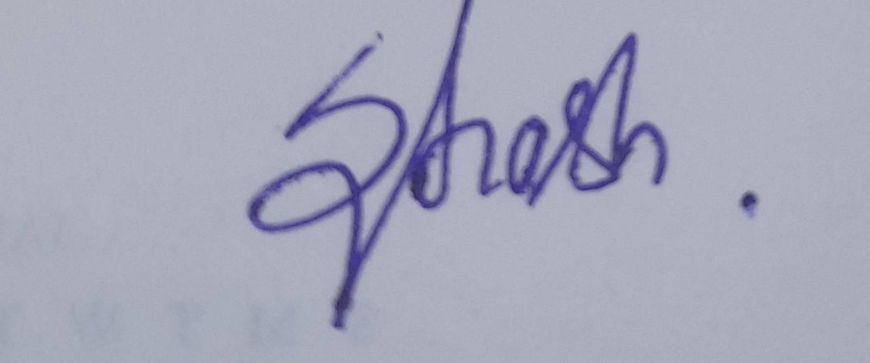
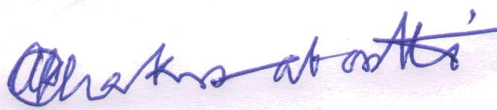

[Signature of expert member] [Signature of authorized representative of Firm]

