Format of Curriculum Vitae (CV) for
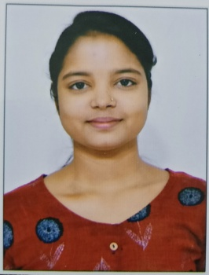
Proposed Key Professional Staff

Position: Junior Research Fellow (GIS)
Name of Firm: Prantik Care the Earth Geo-info Solutions Pvt. Ltd.
Name of Expert: Priya Kumari Shaw
Profession: RS & GIS
Date of Birth: 04.02.2000
Years with Firm/Entity: August, 2023 Nationality: Indian
Membership in Professional Societies: No

Key Qualification:
I have done 30 days internship in Geovale services pvt. Ltd, Kolkata, Sector-v.
Education Details

Sl.No | Name of the Examination | Board/Authority | Year of Passing
1 | M.Sc in Geoinformatics | Kazi Nazrul University | 2023
2 | B.Sc in Geography | Kazi Nazrul University | 2021
3 | Higher Secondary | W.B.B.H.S.E | 2018
4 | Secondary | W.B.B.S.E | 2016

Languages:

Language Known | Reading | Writing | Speaking
English | Excellent | Good | Moderate
Bengali | Excellent | Excellent | Excellent
Hindi | Moderate | Poor | Excellent

Certification:

I, the undersigned, certify that to the best of my knowledge and belief, these data correctly describe me, my qualifications, and my experience. If awarded the Contract, I undertake to work with this Firm only on this assignment.
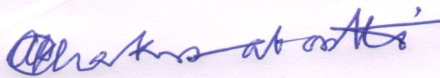
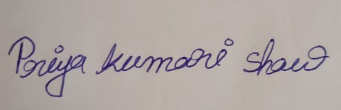
[Signature of expert member] [Signature of authorized representative of Firm]
Date: 18.08.2023
Full name of expert: Priya Kumari Shaw
Full name of authorized representative: Shri Amal Krishna Chakrabortti

