Prantik Care The Earth Geo Info Solutions Pvt. Ltd

*Maa Mati Samaj*

*A Ministry of Corporate Affairs empanelled ISO 9001: 2015 Certified Private Limited Company Operating in the Federals of Remote Sensing, GIS, Information Technology & Survey Engineering*

CIN No: **U72200WB2016PTC217241; Registration No: 217241**

**GST Registration Number: 19AAICP8456G1ZW Udyam Aadhar Registration No: UDYAM-WB-04-0000121**

Position: Business Development Officer (BDO)

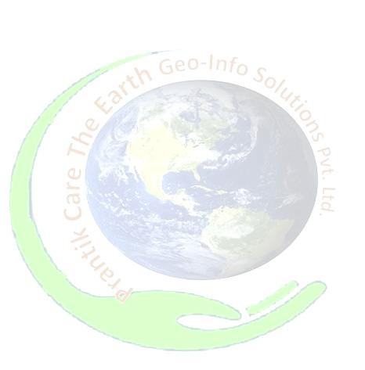

Name of Firm: M/s- Prantik Care The Earth Geo Info Solutions Pvt Ltd

Name of Expert: Mr. Kumar Upavan

Profession: GIS Analyst cum Business Development Officer

Date of Birth: 17.05.1999

Years with Firm/Entity: 3 Months Nationality: Indian

Membership in Professional Societies: No

**Key Work Experiences:**

1. **Lightning Occurrences and Associated Vulnerability**, *Thesis Report for Masters of Remote Sensing Degree* **2024 – 2025**
2. **Project Report on Integrated Geospatial Analysis For LULC, Water Harvesting Suitability, and Forest Resource Mapping with Forest Fire Risk Assessment in Godda District***, Internship**Report on Forest Resource Mapping in Godda District: A Geospatial Perspective* **05/2024 – 07/2024**
3. **A Dissertation Work on Spatial Study Cum Analysis of Murmuta Village in Gola Block, Ramgarh (2020 - 2022),** *Dissertation Work* **2022 – 2022**
4. **An Atlas on Demographic and Socio-Economic Aspects of Bankura District, 2011,** *Computer Aided Mapping and Thematic Atlas* **2021 – 2021**
5. **Traffic Problems in Ranchi City,** *Ground Survey Based Report* **2017 – 2017**

**Education:**

|  |  |  |  |
| --- | --- | --- | --- |
| **Sl. No** | **Name of the Examination** | **Board/Authority** | **Year of Passing** |
| 1 | M. Tech in Remote Sensing | Birla Institute of Technology, Mesra, Ranchi | 2025 |
| 2 | M.A. in Geography | St. Xavier’s College, Ranchi | 2022 |
| 3 | B.A.(Hons) in Geography | St. Xavier’s College, Ranchi | 2020 |
| 4 | Higher Secondary (CBSE), Arts | K. V. Adra, Purulia WB | 2017 |

**Employment Record:**



|  |  |
| --- | --- |
| August’ 25 – Present | **Business Development Officer**, Prantik Care the Earth Geo Info Solutions Pvt Ltd, West Bengal India. Job Role: Acting as Business Development Officer representing the farm in Government and Private Meetings, Project Liaising & Management, Governmental & Non-Governmental Interactions, etc. |
|
|
|
|
| June’ 25 – August 25 | **Junior Research Fellow in (Urban GIS)**, Prantik Care the Earth Geo Info Solutions Pvt Ltd, West Bengal India. Job Role: Acting as Junior Research Fellow (JRF) in Urban GIS team, Digitization, Database Creation, and Analysis cum Inception Report Writing. |
|
|

**Languages:**

|  |  |  |  |
| --- | --- | --- | --- |
| **Language**  **Known** | **Reading** | **Writing** | **Speaking** |
| English | Excellent | Excellent | Excellent |
| Hindi | Excellent | Excellent | Excellent |
| Bengali | Fair | Poor | Excellent | |
| Oriya | Fair | Poor | Good |
| Bhojpuri | Fair | Poor | Good |

**Certification:**

I, the undersigned, certify that to the best of my knowledge and belief, these data correctly describe me, my qualifications, and my experience. If awarded the Contract, I undertake to work with this Firm only on this assignment.



[Signature of expert member] [Signature of authorized representative of Firm] Full name of expert: Mr. Kumar Upavan

Full name of authorized representative: - Shri Amal Krishna Chakrabortti

Date: - The Prantik, 19th August 2025