# Format of Curriculum Vitae (CV) for Proposed Key Professional Staff

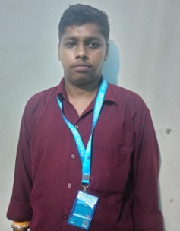Designation: Junior Scientific Officer (Survey)

Name of Firm: Prantik Care The Earth Geo- Info Solution Pvt. Ltd Name of Expert: Sujoy Ghosh

Profession: Junior DGPS Operator, Field Data Collection

Date of Birth: 14.03.2002

Years with Firm/Entity: 3 Years Nationality: Indian Membership in Professional Societies: No

Detailed Tasks Assigned: Collection of Field Data .

* **Key Qualifications:**

|  |  |  |  |  |
| --- | --- | --- | --- | --- |
| Sl.No. | Name of the Examination | Board/Authority | Year of Passing | Percentage (%) |
| 1 | Secondary Examination | WBBSE | 2017 | 26.71 |
| 2 | Higher Secondary | WBCHSE | 2019 | 47.8 |
| 3 | ITI SURVEY | NCVT | 2021 | 78.9 |

* **Employment Record:**

|  |  |
| --- | --- |
| 2022-2025 | **Junior Field Assistant:-**Prantik Care The Earth Geo- Info Solution Pvt. Ltd Santiniketan, Birbhum, West Bengal. |
| Aug’25- Present | **Junior Scientific Officer:-**Prantik Care The Earth Geo- Info Solution Pvt. Ltd Santiniketan, Birbhum, West Bengal. |

* **Project Experiences:-**

**1. Junior Field Assistant:-** Urban Mapping and Geodatabase Creation of Lemmi, Tato and Basar Administrative Townships in Arunachal Pradesh; Client: Department of Town Planning; Government of Arunachal Pradesh.

**2. Junior Field Assistant:-** Urban Mapping and Geo-spatial database generation for Hollongi Donyi Polo Airport Planning and Development Area (Including Hollongi, Kokila and Chengmara) under Papum Pare District of Arunachal Pradesh.

* **Languages:**

| **Language Known** | **Reading** | **Writing** | **Speaking** |
| --- | --- | --- | --- |
| English | Good | Good | Poor |
| Bengali | Excellent | Excellent | Excellent |
| Hindi | Poor | Poor | Excellent |

**Certification:**

I, the undersigned, certify that to the best of my knowledge and belief, these data correctly describe me, my qualifications, and my experience. If awarded the Contract, I undertake to work with this Firm only on this assignment

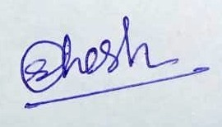

_______________________ ____________________________________

[Signature of expert member] [Signature of authorized representative of Firm]

Date: 25/08/2025

Full name of expert: Sujoy Ghosh