# Format of Curriculum Vitae (CV) for Proposed Key Professional Staff

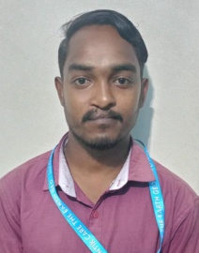

Designation: Junior Scientific Officer (Survey)

Name of Firm: Prantik Care The Earth Geo-Info Solution Pvt. Ltd. .Name of Expert: Shri Sujay Das

Profession: Field Data Collection, Auto CAD Drawing, GPS Operator

Date of Birth: 13.10.2000

Years with Firm/Entity: 3 Years Nationality: Indian Membership in Professional Societies: No

Detailed Tasks Assigned: Collection of Field Data, Team Management, Communication With Office, and Data Integration in Auto CAD Software.

* **Key Qualifications:**

|  |  |  |  |  |
| --- | --- | --- | --- | --- |
| Sl.No. | Name of the Examination | Board/Authority | Year of Passing | Percentage (%) |
| 1 | Secondary Examination | WBBSE | 2018 | 40 |
| 2 | Higher Secondary | WBCHSE | 2020 | 40 |
| 3 | ITI SURVEY | N.S.Q.F | 2022 | 66 |

# Employment Record:

|  |  |  |
| --- | --- | --- |
| Years | Designation | Project Of Work |
| 2022-2023 | Junior Field Assistant | Digital India  Land Record Modernization Program, Government of Arunachal Pradesh. |
| 2023-2024 | Junior Field Assistant-ll | Urban Mapping and Geo database Creation of Lemmi,Tato,Basar Administrative Township in Arunachal Pradesh. |
| 2024-2025 | Junior Field Assistant-ll | Creation of Farmer Database and Supporting Farmer Through Real Time Geospecial Analytics to Increase Farmer Productivity in Agriculture By Machine Learning in Arunachal Pradesh |

* **Languages:**

|  |  |  |  |
| --- | --- | --- | --- |
| **Language Known** | **Reading** | **Writing** | **Speaking** |
| English | Good | Good | Poor |
| Bengali | Excellent | Excellent | Excellent |
| Hindi | Good | Poor | Excellent |

* **Certification:**

I, the undersigned, certify that to the best of my knowledge and belief, these data correctly describe me, my qualifications, and my experience. If awarded the Contract, I undertake to work with this Firm only on this assignment

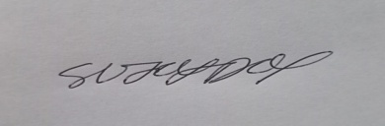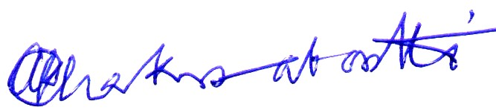

_______________________ ______________________________________

[Signature of expert member] [Signature of authorized representative of Firm]

Date: 22/08/2025

Full name of expert: Sujay Das