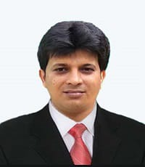
CV of Accountant (Shri Sudip Mandal)
Proposed Position: Accountant
Name of Firm: Prantik Care the Earth Geo-info Solutions Pvt. Ltd.
Name of Expert: Sudip Mandal
Profession: Accountant
Date of Birth: 01/03/1988
Years with Firm/Entity: November, 2024 Nationality: Indian
Membership in Professional Societies: No

Experiences:
- Accountant: Complete Audit report F.Y 2022-23,2023-24 and 2024-25, Prepared pay slip up-to-date, Communication with Auditor regularly, Prepared Annual Financial Budget

Education:
Sl. No | Name of the Examination | Board/Authority | Year of Passing | % Of Marks
1 | Certificate in Accounting | NYKCT | Appearing
2 | Diploma in Geographical Information System & Surveying Technology | International Accreditation Organization | 2017 | 75.55%
2 | B.A | University of Burdwan | 2009 | 51.00%
3 | Higher Secondary | W.B.C.H.S.E | 2006 | 57.10%
4 | Secondary | W.B.B.S.E | 2004 | 56.00%
Employment Record:
November 04,2024 To Present | Accountant:- M/s- Prantik Care The Earth Geo-Info Solutions Pvt. Ltd., Santiniketan, Birbhum, West Bengal, India.  Job Role: Accountant
July 05, 2021 To November 2024 | Accountant:-Shalimar Hatcheris Ltd.,Bolpur Branch,Job Role:-Accounts & Finance
08 September 2019 To June 20 2021 | Accountant:-Swathy Feeds,Sainthia Branch, Job Role:-Accounts & Finance

Languages:

Language Known | Reading | Writing | Speaking
English | Excellent | Good | Moderate
Bengali | Excellent | Excellent | Excellent
Hindi | Excellent | Average | Good
Certification:
I, the undersigned, certify that to the best of my knowledge and belief, these data correctly describe me, my qualifications, and my experience. If awarded the Contract, I undertake to work with this Firm only on this assignment.
Date: 22.08.2025
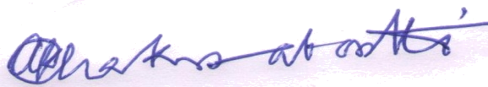
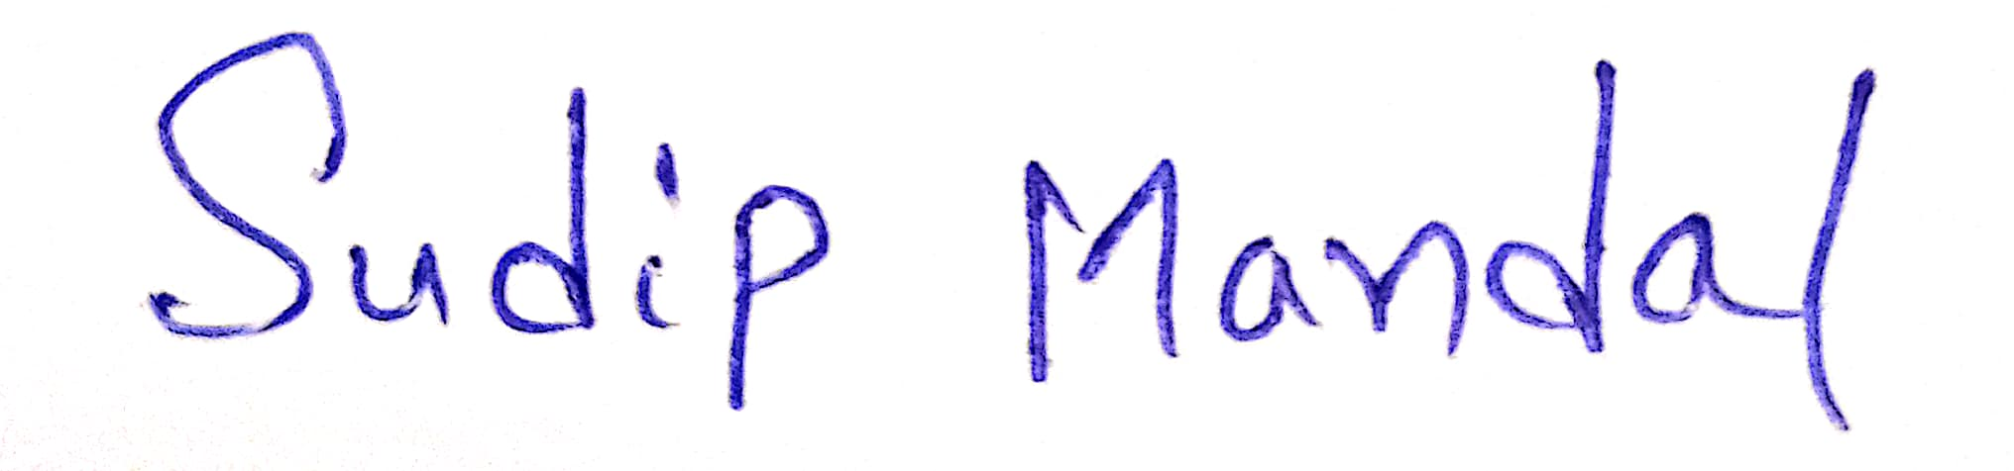

[Signature of expert member] [Signature of authorized representative of Firm]
Full name of authorized representative:
Bharat Gaurav Shri Amal Krishna Chakrabortti

Date: 22.08.2024
Full name of expert: Shri Sudip Mandal

