**Format of Curriculum Vitae (CV) for**

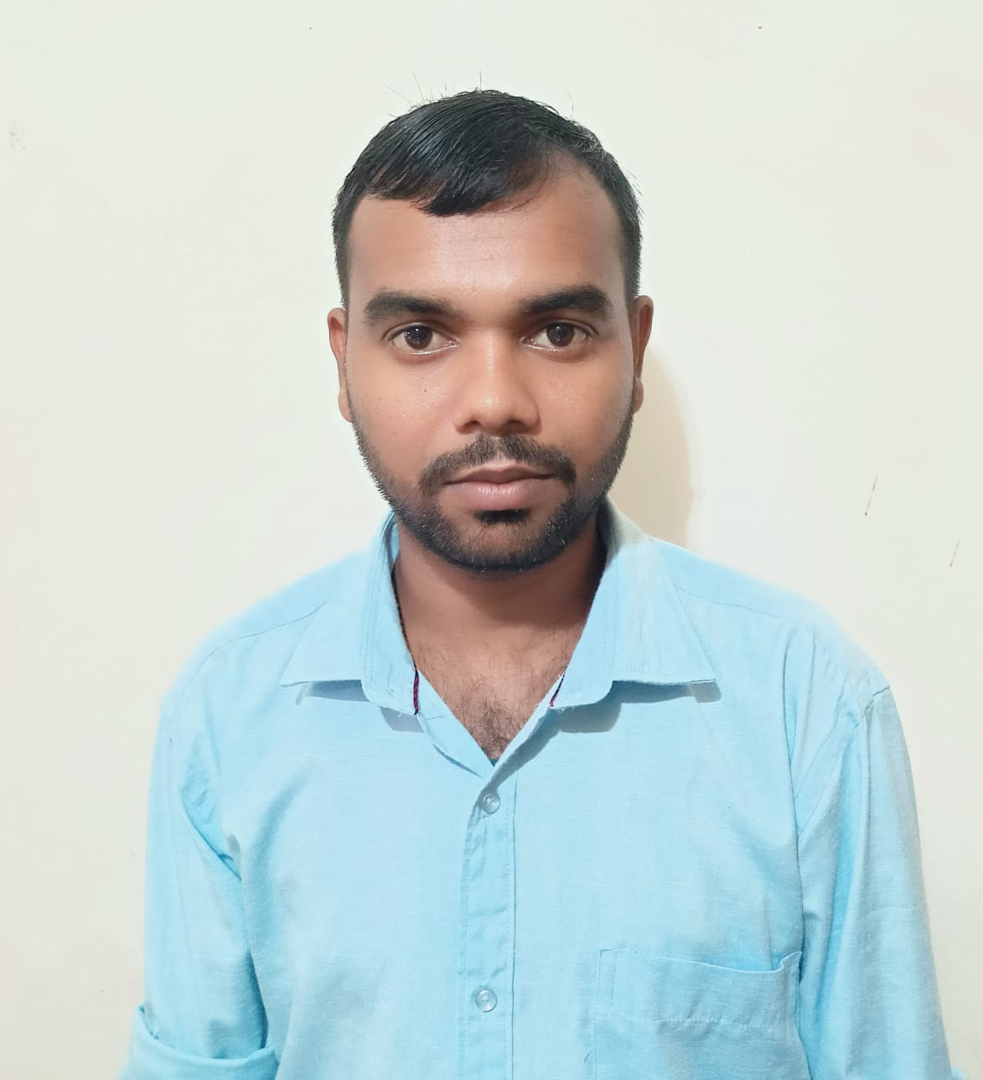

**Proposed Key Professional Staff**

Position: Senior Scientific Officer (GIS)

Name of Firm: Prantik Care the Earth Geo-info Solutions Pvt. Ltd.

Name of Expert: Siddheswar Pandit

Profession: Remote Sensing & GIS Expert

Date of Birth: 18.08.1997

Years with Firm/Entity: August, 2017 Nationality: Indian

Membership in Professional Societies: No

Detailed Tasks Assigned: Primary Base Database Creation, Quality Checking, Analysis, Report writing and Map Layout Preparation.

1. **Senior Scientific Officer (GIS):-** Digital survey work at Haldia Industrial Parks of WBIIDC at Haldia of West Bengal, West Bengal Industrial Infrastructure Development Corporation, West Bengal, India, Status: - Completed.
2. **Scientific Officer (GIS):-** Digitization and preparation of thematic map 1:10K spatial scale for Land Use and Land Cover, Road, Railway, Drainage Network and including integration of the community resource for 20th District under the project “Space Based Information System for Decentralization Planning Update(SIS-DP-Update) for the Arunachal Pradesh”, Status: - Completed
3. **Scientific Officer (GIS):-** Digitization and preparation of thematic map 1:10K spatial scale for Land Use and Land Cover, Road, Railway, Drainage Network 13th District under the project “Space Based Information System for Decentralization Planning Update(SIS-DP-Update) for the Assam”, Status: - Completed
4. **Senior Scientific Officer (GIS):-** Digital survey work at Coochbehar Industrial Parks of WBIIDC at Coochbehar of West Bengal, West Bengal Industrial Infrastructure Development Corporation, West Bengal, India, Status: - Completed.
5. **Senior Scientific Officer (GIS):-** Forest Mapping at Meghatori Mouza of Jharkhand, Koderma Dist, Jharkhand, India, Status: - Completed.
6. **Senior Scientific Officer (GIS):-** Topographic survey at Silsako Beel and its peripheral channel at Guwahati, Guwahati Metropolitan Dev. Authority, Assam, India. Status: - Completed.
7. **Senior Scientific Officer (GIS):-** Digital survey work at Raninagar Industrial Parks

of WBIIDC at Jalpaiguri of West Bengal, West Bengal Industrial Infrastructure Development Corporation, West Bengal, India, Status: - Completed.

1. **Senior Research Fellow (GIS):-**Topographical Survey work by using total station and GPS system at Food Court, Activities and car parking lot for food court within the premises of Gajoldoba Tourism Hub in Jalpaiguri District, West Bengal, India.

Status: - Completed

1. **Senior Research Fellow (GIS):-**, Remote Sensing & GIS Based Identification of Hazardous Industries and Development of Emergency Planning & Response System Arunachal Pradesh, India. Status: - Completed
2. **Senior Research Fellow (GIS):-** Carrying Out the Survey of Road Length, Drain Length Along with GPS Coordinates, Condition of Road .and Drain with Integration in Google Map ; Vyasanagar Municipality, Odisha, India. Status: - Completed.
3. **Senior Research Fellow (GIS):-** Digital Land Records Modernization Program (DLRMP), Department of Land Management, Government of Arunachal Pradesh; East Siang District, Arunachal Pradesh, India. Status-Ongoing
4. **Junior Research Fellow (GIS):-** Sustainable Development of Pasighat Township Using Remote Sensing GIS Cum Spatial Information System, Dept. of State Remote

Sensing Centre, (Department of Science & Technology) Government of Arunachal Pradesh India. Status: - Completed

1. **Junior Research Fellow (GIS):-** Empowering Panchayeti Raj Institutional Spatially (EPRIS),Dept. of West Bengal State Council of Science & Technology, Birbhum, District, West Bengal, India. Status:- Completed
2. **Junior Research Fellow (GIS):-** Mining Plan for Minor Mineral Quarries, West Kemeng, Lohit, Namsai District, Arunachal Pradesh, India. Status:- Completed
3. **Junior Research Fellow (GIS):-** Preliminary Survey for Coal Occurrences in Elephant area and its Vicinity, Arunachal Pradesh, India. Status:- Completed
4. **Junior Research Fellow (GIS):-** Preliminary Survey on Black Quartz or Tourmaline in Mengio area & its Vicinity Under Sagalee Division, Papumpare District, Arunachal Pradesh, India. Status: - Completed
5. **Junior Research Fellow (GIS):-** Digitization of the Bharali River bed Quarries, West Kameng, Arunachal Pradesh, India. Status:- Completed
6. **Junior Research Fellow (GIS):-** Preparation of Detailed Road Network Map Under Bolpur Municipality, Birbhum, West Bengal, India. Status:- Completed
7. **Junior Research Fellow (GIS):-** Preparation of GIS Map of Mirik N.A.A within Mirik N.A.A Area, Marik , West Bengal, India. Status:- Completed
8. **Junior Research Fellow (GIS):-** GIS Based City Based Map of Sainthia Municipality, West Bengal, India. Status:- Completed
9. **Junior Research Fellow (GIS):-** Cadastral Mapping of Lower Subansiri District, Zero Circle, Arunachal Pradesh, India. Status:- Completed
10. **Junior Research Fellow (GIS):-** Investigation of Alubari Rock Quarry, Dept. of Geology Mining, Arunachal Pradesh, India. Status:- Completed

*[Give an outline of expert member’s experience and training most pertinent to tasks on assignment. Describe degree of responsibility held by expert member on relevant previous assignments and give dates and locations. Use about half a page.]*

|  |  |  |  |
| --- | --- | --- | --- |
| **Sl. No** | **Name of the Examination** | **Board/Authority** | **Year of Passing** |
| 1 | M.sc Geospatial Science | Burdwan University | Pursuing |
| 2 | B.Sc in Geography | NSOU | 2021 |
| 3 | Diploma in Geographical Information System & Surveying Technology | International Accreditation Organization | 2017 |
| 4 | Higher Secondary | W.B.B.H.S.E | 2015 |
| 5 | Secondary | W.B.B.S.E | 2013 |

*[Summarize college/university and other specialized education of expert member, giving names of schools, dates attended, and degrees obtained. Use about one quarter of a page.]*

Employment Record:

|  |  |
| --- | --- |
| Aug’30,2017-Aug’2, 2020 | **Junior Research Fellow (GIS): -** Prantik Care The Earth Geo-Info Solutions Pvt. Ltd., Santiniketan, Birbhum, West Bengal, India. Job Role: Digitization, Layout Preparation, |
| Aug’2-Present | **Senior Research Fellow (GIS): -** Prantik Care The Earth Geo-Info Solutions Pvt. Ltd., Santiniketan, Birbhum, West Bengal, India. Job Role: Database Creation, Digitization, Layout Preparation |
| Jun’02,2022- Present | **Senior Scientific Officer (GIS): -** Prantik Care The Earth Geo-Info Solutions Pvt. Ltd., Santiniketan, Birbhum, West Bengal, India. Job Role: Primary Base Database Creation, Quality Checking, Analysis, Report writing and Map Layout Preparation. |

*[Starting with present position, list in reverse order every employment held. List all positions held by expert member since graduation, giving dates, names of employing organizations, titles of positions held, and locations of assignments. For experience in last ten years, also give types of activities performed and client references, where appropriate. Use about two pages.]*

Languages:

|  |  |  |  |
| --- | --- | --- | --- |
| **Language Known** | **Reading** | **Writing** | **Speaking** |
| English | Excellent | Excellent | Moderate |
| Bengali | Excellent | Excellent | Excellent |
| Hindi | Excellent | Excellent | Excellent |

*[For each language indicate proficiency: excellent, good, fair, or poor; in speaking, reading, and writing]*

**Certification:**

I, the undersigned, certify that to the best of my knowledge and belief, these data correctly describe me, my qualifications, and my experience. If awarded the Contract, I undertake to work with this Firm only on this assignment.

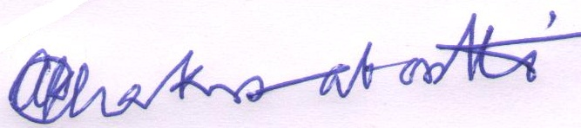

[Signature of expert member] [Signature of authorized representative of Firm]

Date: 19.08.2025

Full name of expert: Siddheswar Pandit

Full name of authorized representative: Shri Amal Krishna Chakrabortti