Ref No: PCTEGIS/ Offc.Admin/2025-26/ ………. Dated: the Prantik, 21th. August, 2025
Show Cause Notice
To
Shri Subhrangshu Mazilla
JSO (Survey)
Prantik Care The Earth Geo Info Solutions Pvt Ltd

Dear Subhrangshu Mazilla

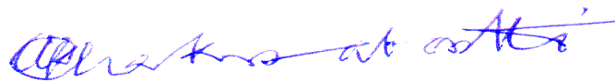
You did not turn up to office Till now (11:00 AM) Inspire of Notification From this office you are Requested to show cause as to why no Disciplinary Action Will not be taken against you as par Company Rules. Within 24 house Hence.

(Bharat Gaurav Shri Amal KrishnaChakrabortti)
Director cum Chif Administrative Officer,
Prantik Care The Earth Geo Info Solutions Pvt Ltd.
Dated: the Prantik, 21th. August, 2025

