Format of Curriculum Vitae (CV) for
Proposed Key Professional Staff
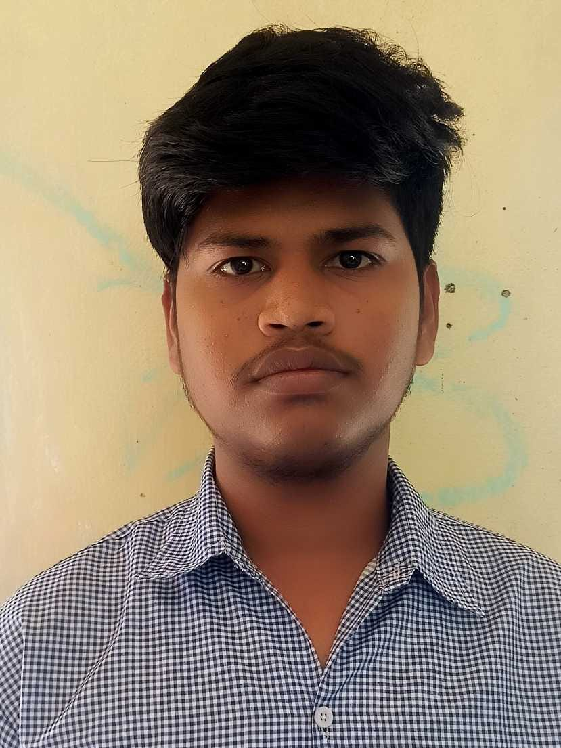
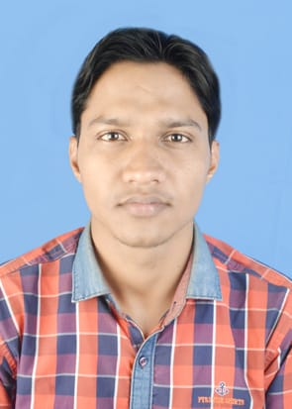
Proposed Position: Administrative Assistant
Name of Firm: M/s- Prantik Care the Earth Geo-info Solutions Pvt. Ltd.
Name of Expert: Santosh Mandal
Profession: Administrative Assistant
Date of Birth: 05/04/1997
Years with Firm/Entity: November, 2024 Nationality: Indian
Membership in Professional Societies: No

Sl.No | Name of the Examination | Board/Authority | Year of Passing
1 | B.A in Bengali | Burdwan University | 2017
2 | Higher Secondary | W.B.C.H.S.E | 2014
3 | Secondary | W.B.B.S.E | 2012

Employment Record:
November 04,2024 To Present | Administrative Assistant Prantik Care The Earth Geo-Info Solutions Pvt. Ltd., Santiniketan, Birbhum, West Bengal, India. Job Role: Administrative Assistant

Languages:
Language Known | Reading | Writing | Speaking
English | Excellent | Good | Fair
Bengali | Excellent | Excellent | Excellent
Hindi | Good | Fair | Good

[For each language indicate proficiency: excellent, good, fair, or poor; in speaking, reading, and writing]

Certification:

I, the undersigned, certify that to the best of my knowledge and belief, these data correctly describe me, my qualifications, and my experience. If awarded the Contract, I undertake to work with this Firm only on this assignment.
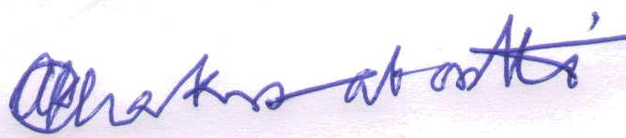


[Signature of expert member] [Signature of authorized representative of Firm]

Date: 04.11.2024
Full name of expert: Santosh Mandal
Full name of authorized representative: Shri Amal Krishna Chakrabortti

