CV of Junior Research Fellow (Kumari Monidipa Sarkar)
Proposed Position: GIS Engineer Name of Firm: Prantik Care The Earth Name of Expert: Monidipa Sarkar
Date of Birth: 04/12/1999
Years with Firm/Entity:01 Nationality: Indian
Key Qualification:
1. Junior Research Fellow: Space Based Information Support for Decentralized Planning (SIS-DP): Phase II, Prantik Care The Earth Geo Info Solutions Pvt. Ltd.

Education: B.Sc. (Geography); M.Sc. in Geoinformatics;

Sl. No | Name of the Examination | Board/Authority | Year of Passing | % of Marks
1 | M.Sc. in Geoinformatics | Kazi Nazrul  University | 2023 | 6.74
2 | B.Sc. (Hons) in Geography | The University of Kazi Nazrul University | 2021 | 7.89

Certification:
I, the undersigned, certify that to the best of my knowledge and belief, these data correctly describe me, my qualification, and my experience. If awarded the contract, I undertake to work with this Firm only on this assignment.

Date: 18.08.2023
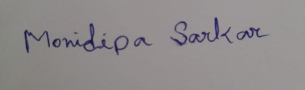
Full name of expert: Monidipa Sarkar Full name of authorized representative:

