Prantik Care The Earth Geo Info Solutions Pvt. Ltd

*Maa Mati Samaj*

*A Ministry of Corporate Affairs empanelled ISO 9001: 2015 Certified Private Limited Company Operating in the Federals of Remote Sensing, GIS, Information Technology & Survey Engineering*

CIN No: **U72200WB2016PTC217241; Registration No: 217241**

**GST Registration Number: 19AAICP8456G1ZW Udyam Aadhar Registration No: UDYAM-WB-04-0000121**



Position: Junior Research Fellow (GIS)

Name of Firm: M/s- Prantik Care The Earth Geo Info Solutions Pvt Ltd

Name of Expert: Shri Kajal Kumar Mandal

Profession: Junior Research Fellow (GIS)

Date of Birth: 23.03.2000

Years with Firm/Entity: 01 Nationality: Indian

Key Qualifications:

1. **Junior Research Fellow (GIS):-** Digital Land Records Modernization Program (DLRMP), Department of Land Management, Government of Arunachal Pradesh; East Siang District, Arunachal Pradesh, India. Status - Ongoing.

**2. Junior Research Fellow (GIS**):- Creation of farmer database and supporting farmer through real time geospatial analytics to increase farmer productivity in agriculture by mechine learning.Government of Arunachal Pradesh; East Siang District, Arunachal Pradesh, India. Status - Ongoing.

**3. Team Leader:-**  Creation of farmer database and supporting farmer through real time geospatial analytics to increase farmer productivity in agriculture by mechine learning.Government of Arunachal Pradesh; Lower Subansiri District, Arunachal Pradesh, India. Status - Ongoing.

**Education Details:-**

|  |  |  |  |
| --- | --- | --- | --- |
| **Sl. No** | **Name of the Examination** | **Board/Authority** | **Year of Passing** |
| 1 | P.G Diploma In Applied Geoinformatics | Jadavpur University | 2023 |
| 2 | B.Sc. in Geography | West Bengal State University | 2021 |
| 3 | Higher Secondary | W.B.B.H.S.E | 2018 |
| 4 | Secondary | W.B.B.S.E | 2016 |

**Employment Record:-**

|  |  |
| --- | --- |
| Aug. 12.2024 Present | Junior Research Fellow (GIS): - Prantik Care The Earth Geo-Info Solutions Pvt. Ltd., Santiniketan, Birbhum, West Bengal, India. |

Prantik Care The Earth Geo-Info Solutions Pvt. Ltd; Head Offce: 59 D, Adarsha nagar West, Kolkata-

700061; Branch Office: 3/14, K B G Sarani, Prantik Township, Santiniketan, Birbhum, West Bengal

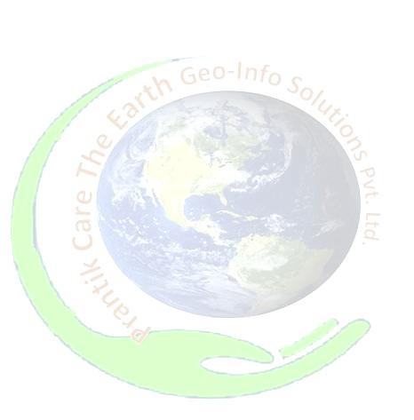

**Languages:**

|  |  |  |  |
| --- | --- | --- | --- |
| **Language Known** | **Reading** | **Writing** | **Speaking** |
| English | Excellent | Good | Moderate |
| Bengali | Excellent | Excellent | Excellent |
| Hindi | Poor | Poor | Excellent |

**Certification:**

I, the undersigned, certify that to the best of my knowledge and belief, these data correctly describe me, my qualifications, and my experience. If awarded the Contract, I undertake to work with this Firm only on this assignment.



[Signature of expert member] [Signature of authorized representative of Firm]

Full name of authorized representative: -

Shri Amal Krishna Chakrabortti

Full name of expert:- Kajal Kumar Mandal

Date: - 19th, October, 2025