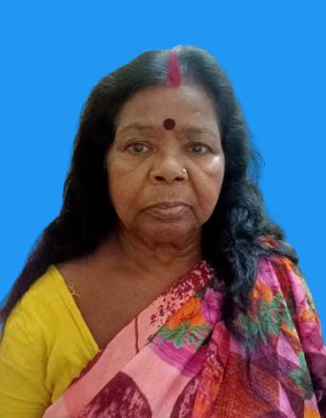
Format of Curriculum Vitae (CV) for
Professional Staff

Proposed Position: Office Peon
Name of Firm: M/s- Prantik Care the Earth Geo-info Solutions Pvt. Ltd.
Name of Expert: Srimati Chabi Lohar
Profession: Group-D
Date of Birth: 01/01/1967
Years with Firm/Entity: January, 2016 Nationality: Indian
Membership in Professional Societies: No

Sl.No | Name of the Examination | Board/Authority | Year of Passing
1 | Class V | W.B.C.H.S.E | 1977
2 | Class VIII | W.B.C.H.S.E | 1980

Employment Record:
August 02,2016 To Present | Office Assistant, M/s- Prantik Care The Earth Geo Info Solutions Pvt Ltd
June 2014 to August’01’2016 | Office Assistant, M/s- Prantik Care The Earth

Languages:
Language Known | Reading | Writing | Speaking
English | Very Poor | Very Poor | Very Poor
Bengali | Good | Poor | Excellent
Hindi | Very Poor | Very Poor | Very Poor

Certification:

I, the undersigned, certify that to the best of my knowledge and belief, these data correctly describe me, my qualifications, and my experience. If awarded the Contract, I undertake to work with this Firm only on this assignment.
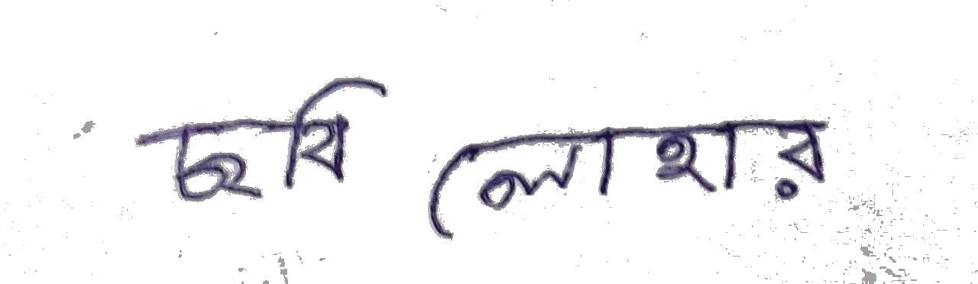
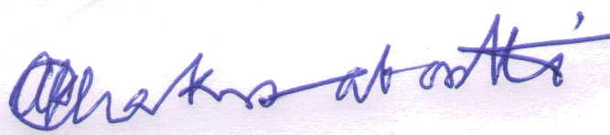

[Signature of Incumbent] [Signature of authorized representative of Firm]

Date: 02.08.2016
Full name of expert: Srimati Chabi Lohar
Full name of authorized representative: Shri Amal Krishna Chakrabortti

