CURRICULUM VITAE
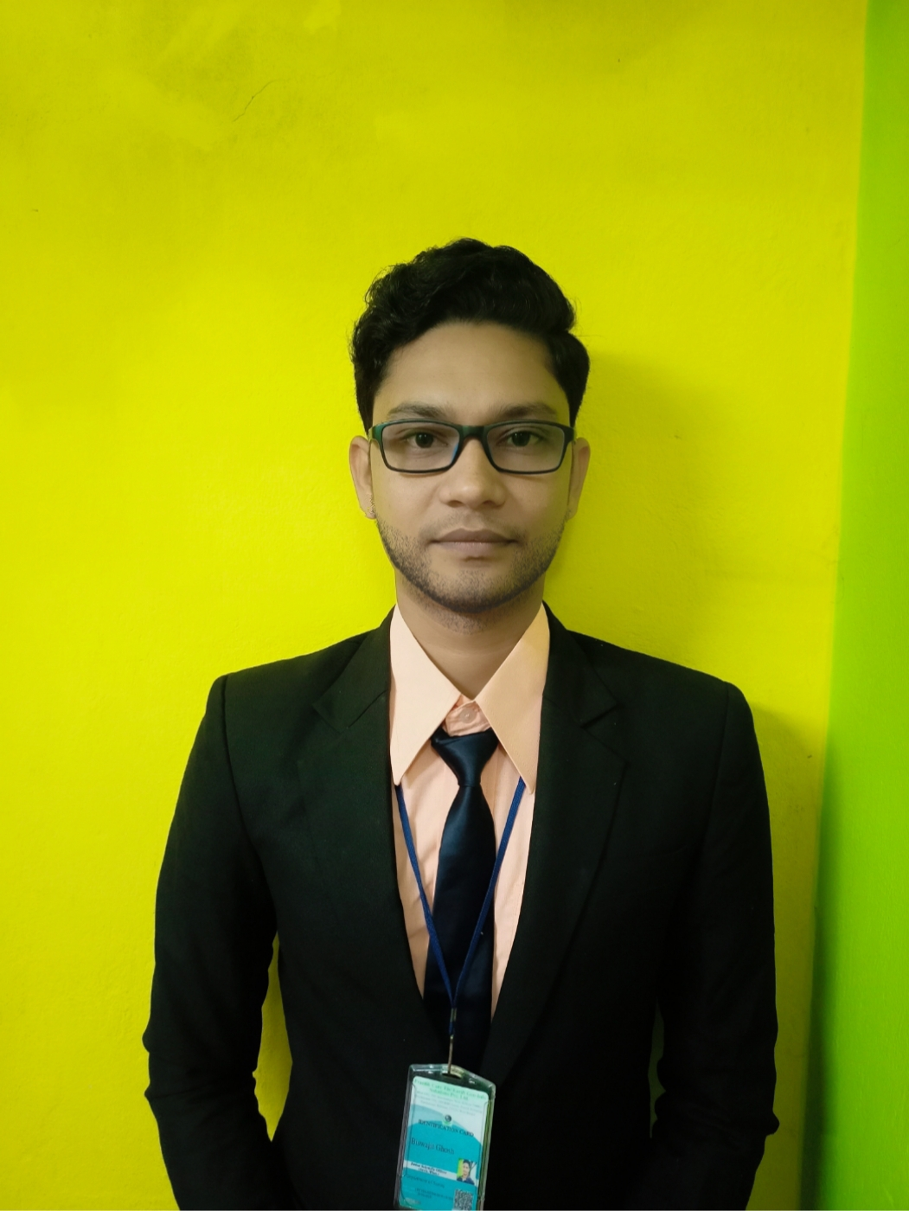
Current Position: Additional Scientific Officer (CAD/Civil)
Name of Firm: Prantik Care the Earth Geo-info Solutions Pvt. Ltd.
Name of Expert: Biswajit Ghosh
Profession: Civil Engineer
Date of Birth: 26-07-1994
Years with Firm/Entity: 14-08-2019 Nationality: Indian
Employment Code: PCTEGIS/HR/2016/012
Membership in Professional Societies: Prantik Care The Earth
Detailed Tasks Assigned:- Monitor and simplify the work of Dept. of Arch & Planning, Prepare Planning for the new works, Tender works.
Key Qualifications: Expert in Software – AutoCAD, Civil 3d, Map 3d, Photoshop CC, Word, Excel, Processing field Survey data, drawing, Instrument use – Auto Level, Total Station(Trimble, Leica, Sokia, Topcon, South, Foif), DGPS ( Leica, Sokia, Topcon, Sino, Foif), Mobile LiDAR ( Pegasus- II),
Employment Record: Presently working on Prantik Care The Earth Geo Info Solution Pvt. Ltd. as Senior Scientific Officer (Architecture & Planning)
Projects Experience: -
- Urban Mapping and Geo-spatial Database generation for Hollongi Donyi Polo Airport Planning and Development Area (Including Hollongi, Kokila and Chengmara) under Papum Pare District of Arunachal Pradesh, Working on Field Data and AutoCAD,

- Digital Survey of Cooch Behar Industrial Park, Cooch Behar, West Bengal, Superimpose data on the LR & RS sheet and Prepare Details Maps Under dept. of West Bengal Industrial Infrastructure Development Corporation

- Digital Survey of Raninagar Industrial Park, Raninagar, Jalpaiguri, West Bengal, Superimpose data on the LR & RS sheet and Prepare Details Maps Under dept. of West Bengal Industrial Infrastructure Development Corporation

- Prepare Detail Report on Silsako Beel & its Peripheral Channel with Guwahati Metropolitan Development Authority(GMDA), Designation : Project P.I, Draftsman
- Preparation of details map of Matia Under Assam Industrial Development Corporation. (AIDC) , Designation : Principal Investigator, Draftsman
- Preparation of details site plan of Gajoldoba under West Bengal Tourism Development Corporation Limited.(WBTDCL), Designation : Principal Investigator, Draftsman
- Prepare Detail Topographical Map of All the existing and new propose area map under West Bengal Police Housing Infrastructure Development Corporation Limited,(WBPHIDCL), Designation : Principal Investigator, Draftsman
- Cadastral Survey and prepare Map of Mebo & Namsing Circle under DILRMP Arunachal Pradesh, Designation : Draftsman,
- Cadastral Survey of East Siang & Sille – Oyan Circle , Pasighat Circle , Balijan Circle. Designation : Draftsman,
- Survey of Pasighat Town Road and Drainage Network under Pasighat Smart City Development Corporation Limited, Designation : Principal Investigator, Draftsman
- Working with Department of Industry Gov. of Arunachal Pradesh for the preparation of 3d modelling and Infrastructural Plan of the existing industry. Designation : Draftsman,
- DPR Preparation for existing single line Railway track from Amethi to Janghai, Uttar Pradesh , India, As the In charge of the Project. Organization – GG survey Consultancy, Client – K & J Project Pvt. Ltd.
- DPR Preparation for NH 27 Udaypur to Palanpur as Mobile LiDAR operator & Survey In charge. Organization – GG survey Consultancy, Client- Clove Technologies Pvt. Ltd.
- DPR Preparation for SH 9 Durgapur to Bankura Project.
Organization – GG survey Consultancy, Client- Arctech Consultants Pvt. Ltd.
- Project Investigator at Shakambhari Ispat & Power Ltd., Purulia, WB
Construction of new unit , Organization – SIPL
- Work in Muhane & East Kankai river survey as a supporting staff with Advance Planning Investigation & Project Preparation official to do survey work and create Cross & Long Profile of the river.
Organization – GG survey Consultancy,
- Survey & Drafting in AutoCAD of NH 67 Gadag to Hosapete 4 Lane Highway work of 92 KM of Road with 22 KM Bypass
Organization – GG survey Consultancy,
- Quantity Estimation Mines at Ghangri, Jharkhand, with DGPS and Drones
Organization – GG survey Consultancy

Educational Qualifications:
Name of the Examination | Board/Authority | Year of Passing
Road Designing | Rajiv Gandhi Training Institute, Guskara | 2021
Diploma in Civil Engineering | WBSCTE | 2015
Certificate Course in Survey | Vocational Training | 2012
Higher Secondary | W.B.C.H.S.E | 2011
Secondary | W.B.B.S.E | 2009
Language known:
Language Known | Reading | Writing | Speaking
English | Good | Good | Good
Bengali | Excellent | Excellent | Excellent
Hindi | Excellent | Poor | Excellent

Certification:

I, the undersigned, certify that to the best of my knowledge and belief, these data correctly describe me, my qualifications, and my experience. If awarded the Contract, I undertake to work with this Firm only on this assignment.

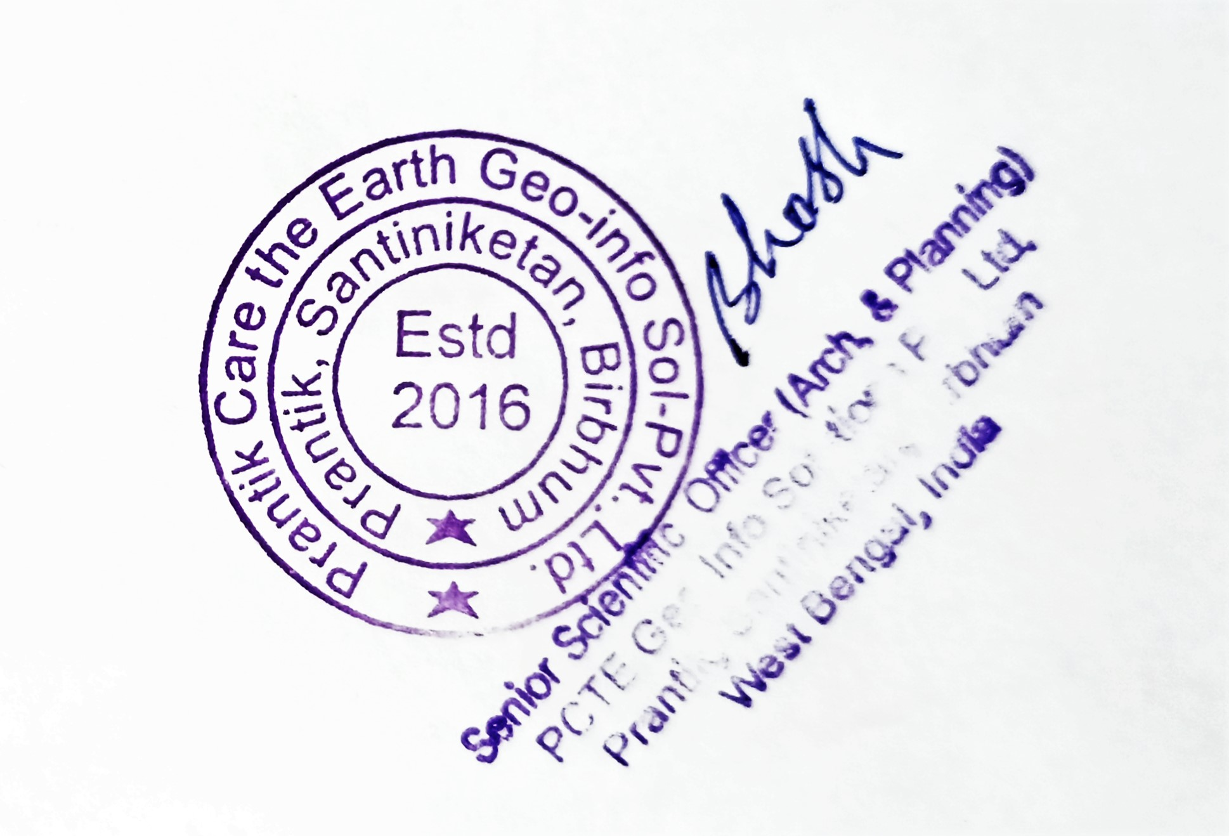
[Signature of expert member] [Signature of authorized representative of Firm]

Date: 20.08.2025 Full name of expert: Biswajit Ghosh

Full name of authorized representative: __________________________________________

