# Format of Curriculum Vitae (CV) for Proposed Key Professional Staff

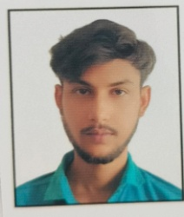Designation: Junior Field Assistant (Survey)

Name of Firm: Prantik Care The Earth Geo-Info Solution Pvt. Ltd. .Name of Expert: Shri Ayan Maji

Profession: Prism Man as assistant surveyor

Date of Birth: 12.10.2000

Years with Firm/Entity: 3 Month Nationality: Indian Membership in Professional Societies: No

Detailed Tasks Assigned:

* **Key Qualifications:**

|  |  |  |  |  |
| --- | --- | --- | --- | --- |
| Sl.No. | Name of the Examination | Board/Authority | Year of Passing | Percentage (%) |
| 1 | Secondary Examination | WBBSE | 2016 | 45.8 |
| 2 | Higher Secondary | WBCHSE | 2018 | 48 |
| 3 | Vocational Education | WBSCTVESD | 2018 | 90 |

* **Employment Record:**

|  |  |  |
| --- | --- | --- |
| Years | Designation | Project Of Work |
| 2025 | Junior Field Assistant | Creation of Farmer Database and Supporting Farmer Through Real Time Geospecial Analytics to Increase Farmer Productivity in Agriculture By Machine Learning in Arunachal Pradesh.  Formulation of GIS Based Comprehensive Development Plan for Boleng, District H.Q of Siang District, Arunachal Pradesh. |

* **Languages:**

|  |  |  |  |
| --- | --- | --- | --- |
| **Language Known** | **Reading** | **Writing** | **Speaking** |
| English | Good | Poor | Poor |
| Bengali | Excellent | Excellent | Excellent |
| Hindi | Poor | Poor | Poor |

* **Certification:**

I, the undersigned, certify that to the best of my knowledge and belief, these data correctly describe me, my qualifications, and my experience. If awarded the Contract, I undertake to work with this Firm only on this assignment

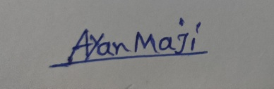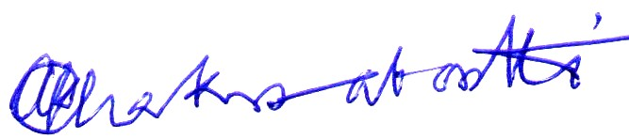

_______________________ ______________________________________

[Signature of expert member] [Signature of authorized representative of Firm]

Date: 22/08/2025

Full name of expert: Ayan Maji